**React**

* React is a javascript library for making interfaces.
* It is a front-end web development framework.
* 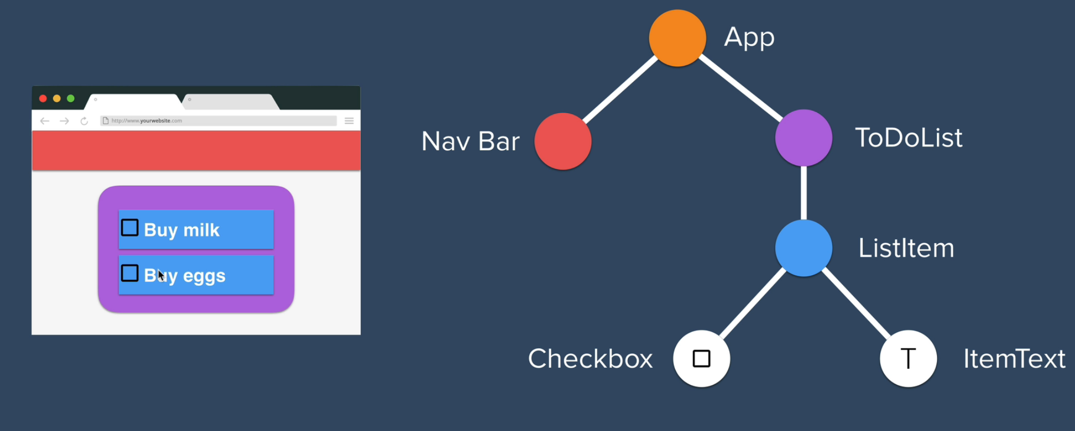

JSX

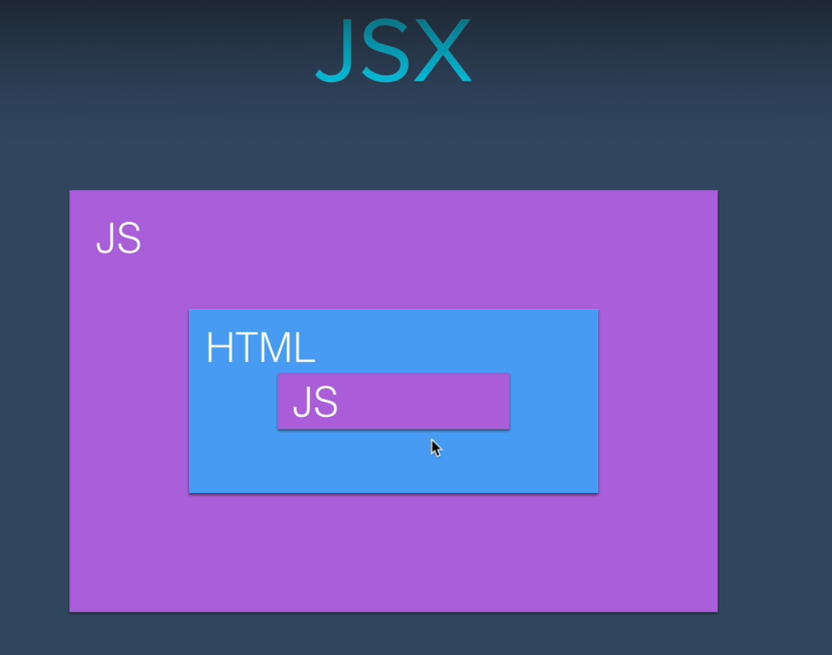

* JSX allows us to insert html codes inside a javascript file and javascript codes inside an HTML file.
* To start using react, we have to search and install react dependency as well as react-dom dependency.
* Then, require those dependencies and bind them to some variables.
* In every React app, there is always a div created by default having an id = “root”.
* Start building the react-app using the render method which is there in the react-dom module.

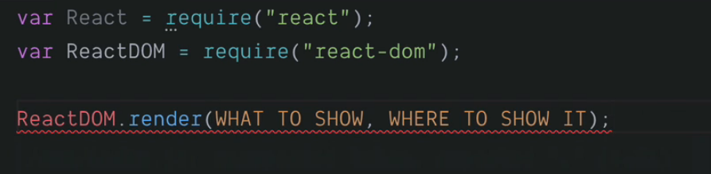

e.g.,



* There is also a third argument in the render function, which is the call-back function and this is optional.
* Here, we are able to write plain HTML code inside a javascript file. This is so because in JSX, a compiler takes the HTML code and converts it into plain javascript file. We get this compiler by requiring react in our javascript (index.js) file.
* The compiler used here is ‘Babel’ which converts higher javascripts such as JSX, ES6, ES7 and so on to Vanilla Javascript which can be get rendered by any browser out there.
* The same change can be implemented using vanilla javascript using

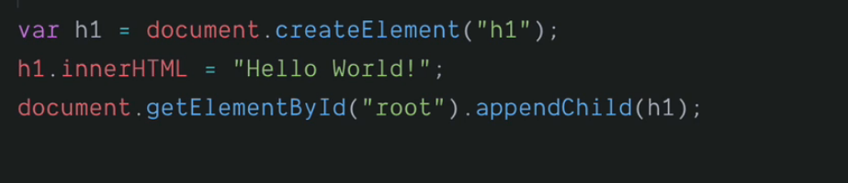

* In react, instead of requiring any dependency, we can import it from the relevant dependencies. It helps us in modularizing our code better.
* 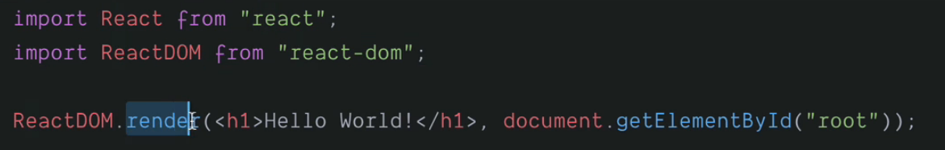
* The render function accepts only a single HTML element. So, if we have more than one HTML element, we can put them inside a div so that the render function interpret div as a single HTML element.

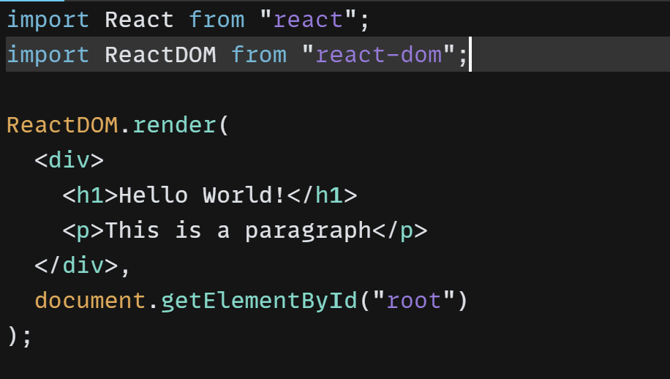

Javascript Expressions in JSX

* To insert a javascript code inside an HTML element in JSX, simply wrap the javascript code into a pair of curly braces.
* In JSX, we can put only javascript expression inside the curly braces and not statements (if-else statement).
* 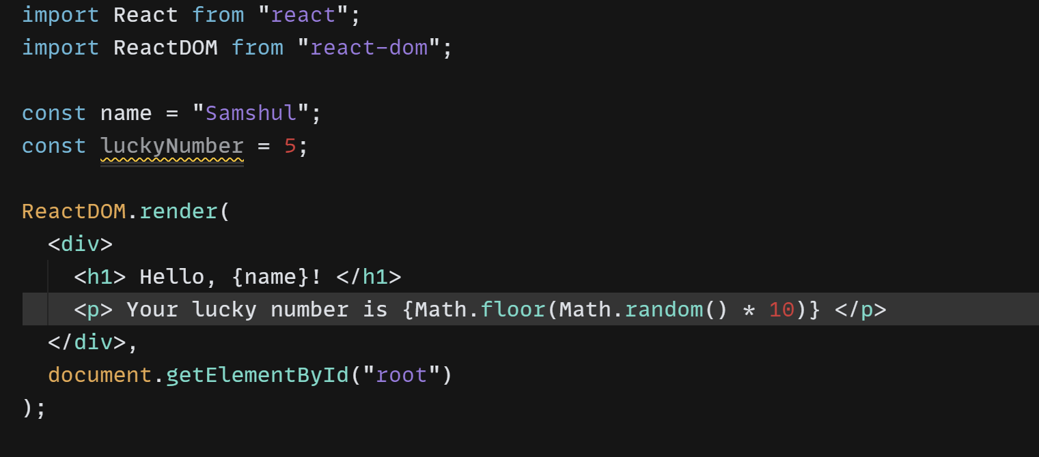

JSX Code Practice:

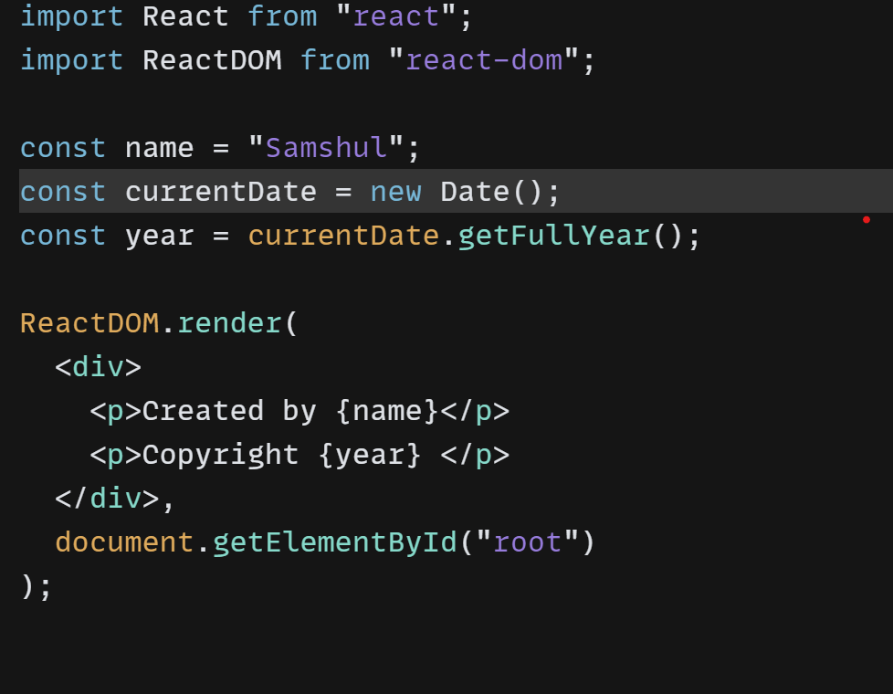

Note: We can get the copyright year dynamically by creating a new **Date()** object and using the **getFullYear()** method on it.

JSX Attributes & Styling React Elements

* In JSX, the name for **class** attribute in HTML and CSS is **className**. So, if we use class attribute in our html code, even though react interprets it, it will throw a warning.
* The attribute name in JSX in always in camelCase format.

Inline Styling for React Elements

* We can add inline CSS in HTML using the style attribute as



* But, JSX supports only JSON objects and it doesn’t interpret the style attribute it happens in HTML. Instead, it is interpreted as a string. So, we need to add JSON object instead of inline CSS property.
* In JSON, the property: value is not a string as in Inline HTML. Instead, only the value is a string and different properties are separated using comma and not by using semi-colon.



* We can also add multiple inline properties by creating a Javascript object.

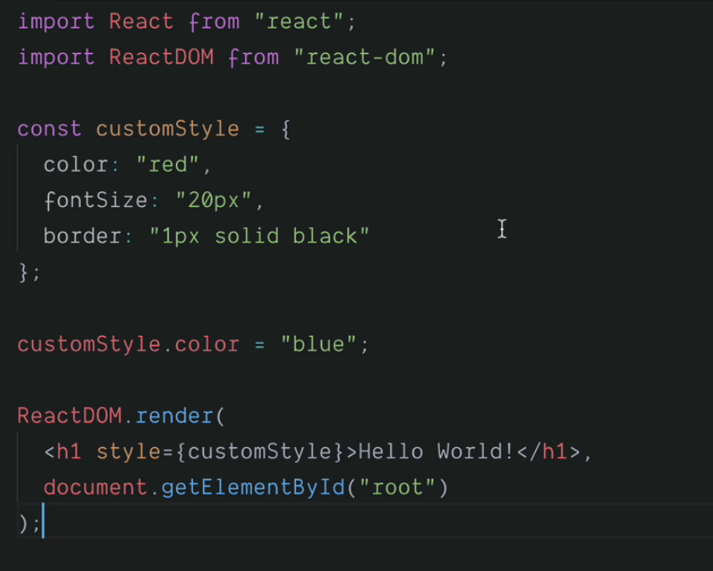

* The benefit of using inline styling is that we can change the style dynamically (on the go) without altering the rendering code.
* Practice:

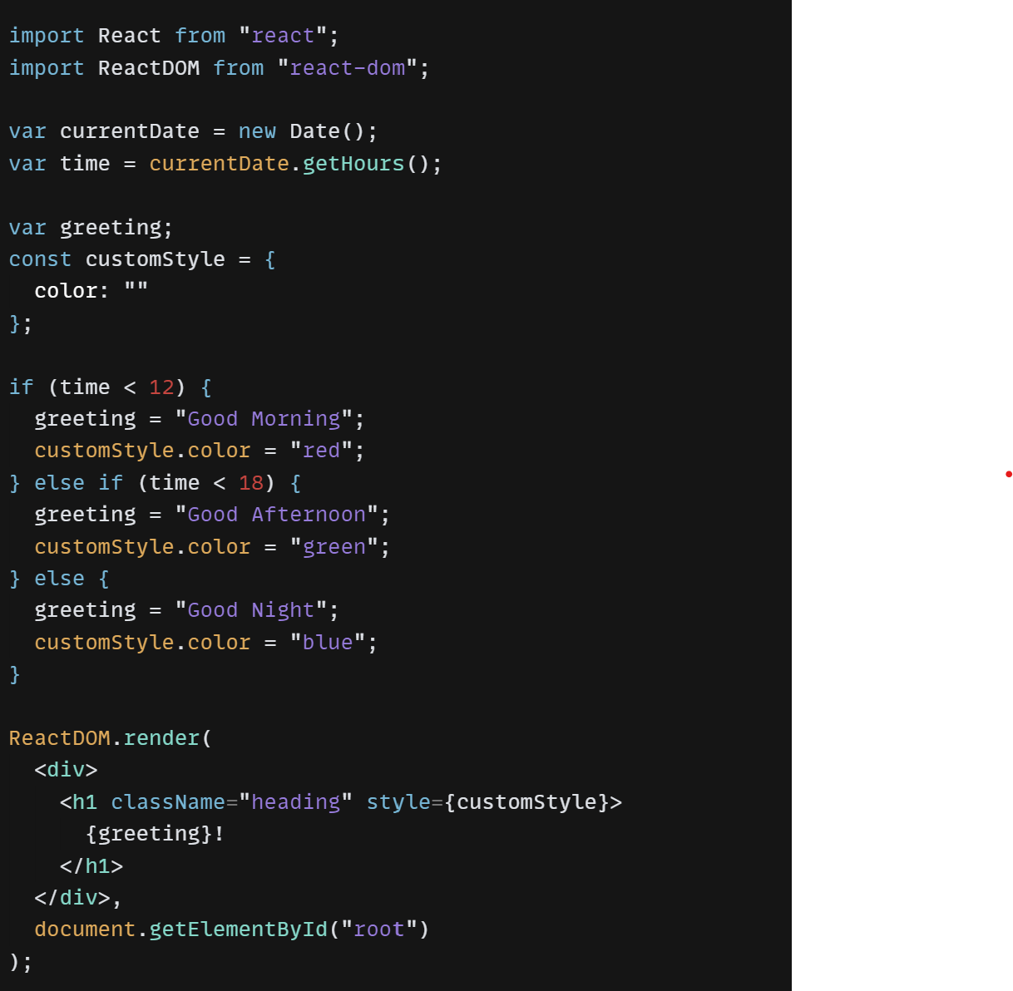

Note:

* In the above code, we can also use let instead of var keyword for greeting.
* let is the block scoped version of var , and is limited to the block (or expression) where it is defined.
* If we use let inside of a block, i.e. a for loop, the variable is only available inside of that loop. let has a block scope.

React Components

* React components are reusable, independent and isolated building blocks of a React application that encapsulate a piece of user interface and its behaviour.
* In React, components can be of two types: class components and functional components.
* Class components are defined using ES6 classes and they inherit from the React.Component class.
* They have a render method that returns a React element, which describes what should be displayed on the screen. Class components also have lifecycle methods that allow developers to hook into different stages of a component's lifecycle.
* Functional components, on the other hand, are defined using JavaScript functions. They are simpler and more lightweight than class components, and they don't have lifecycle methods. They simply take some input data (called "props") and return a React element.

For Example:

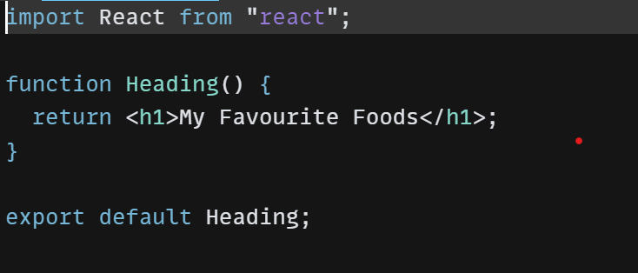

In the index.js file, we have to import this component as

import List from “./componenets/List.jsx”

Import, Export and Modules

* In React, import is used to bring modules or components from external files into the current file.
* In JavaScript, the export keyword is used to export a function, object, or a value from a module to be used in another module.
* **import** and **export** are a part of the ES6 module system, which is the default way of importing and exporting code in modern JavaScript applications.
* When we import a module/ components, the default value gets imported and the name of the variable can be anything.
* To export more than one result, we can use curly braces to export them.

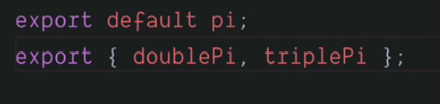

* But, to import a value which is not default, the variable name matters and it must be the same as it is there in the module from where it is being imported.



* 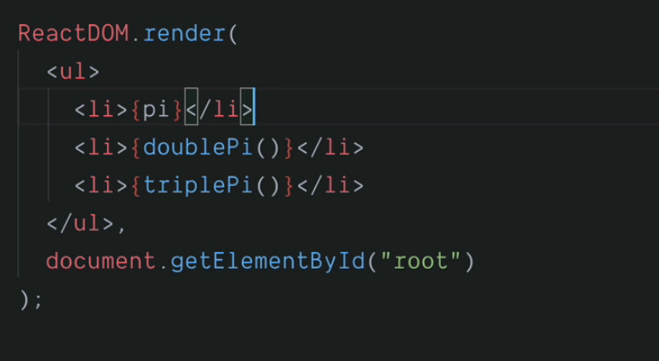
* We can also import everything from a component using asterisk(*) by providing a name so that we can use it to access the exported contents in the program later. This is known as “wild card import”.



In this case, the exported content will be like:

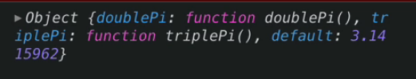

And, we can use it into our program as:

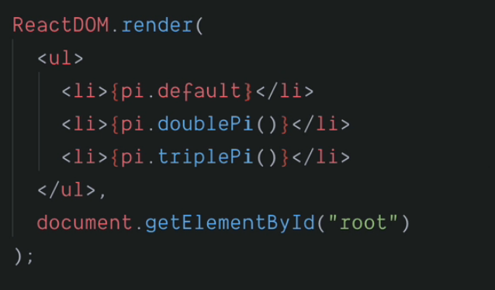

* By using the wild card import, we lose the benefit of having a default export. That is why, the wild card import is always discouragerd.
* The functions of require in Node and import in ES6 are quite similar.

Creating first React App

1. Check if the npm is updated or not.
2. Use the command

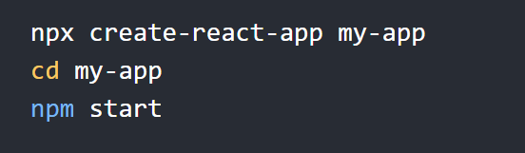

Here,

* my-app is the name of the react project.
* **npx create** will install the necessary dependencies for the app such as react, react-dom, react-script, etc.
* **npm start** will start the app line on our local environment, i.e., localhost:3000

React Properties (Props)

* React props are a way to pass data from a parent component to a child component in React.
* Props are similar to function arguments, in that they allow you to customize the behaviour of a component and make it more dynamic.
* Props are passed down to a component as an object, and are read-only within that component. This means that a child component cannot modify its own props directly.
* Props in React are similar to attributes in HTML.



* Card Component

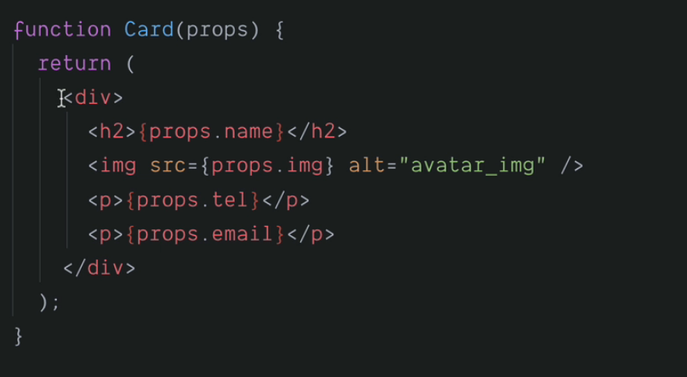

* The properties are being passed as an object and can be accessed using dot (.) notation.

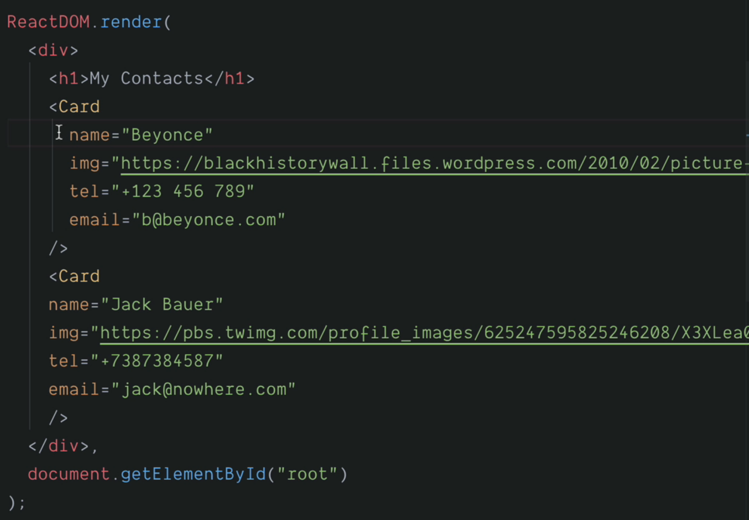

* The main difference between HTML attributes and React props is that a=HTML attributes are pre-defined while the properties in react props are totally determined by the user.
* HTML Attributes:

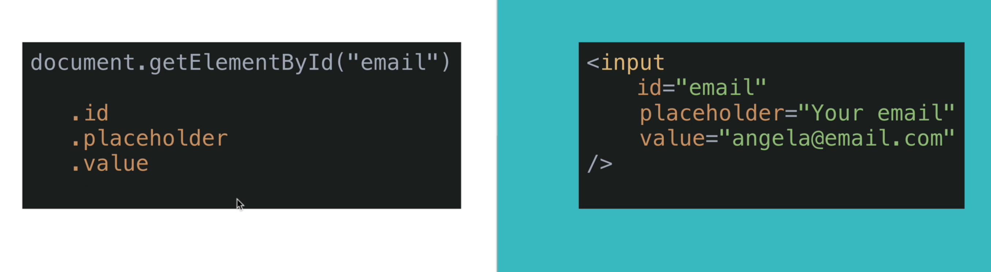

* React Props:

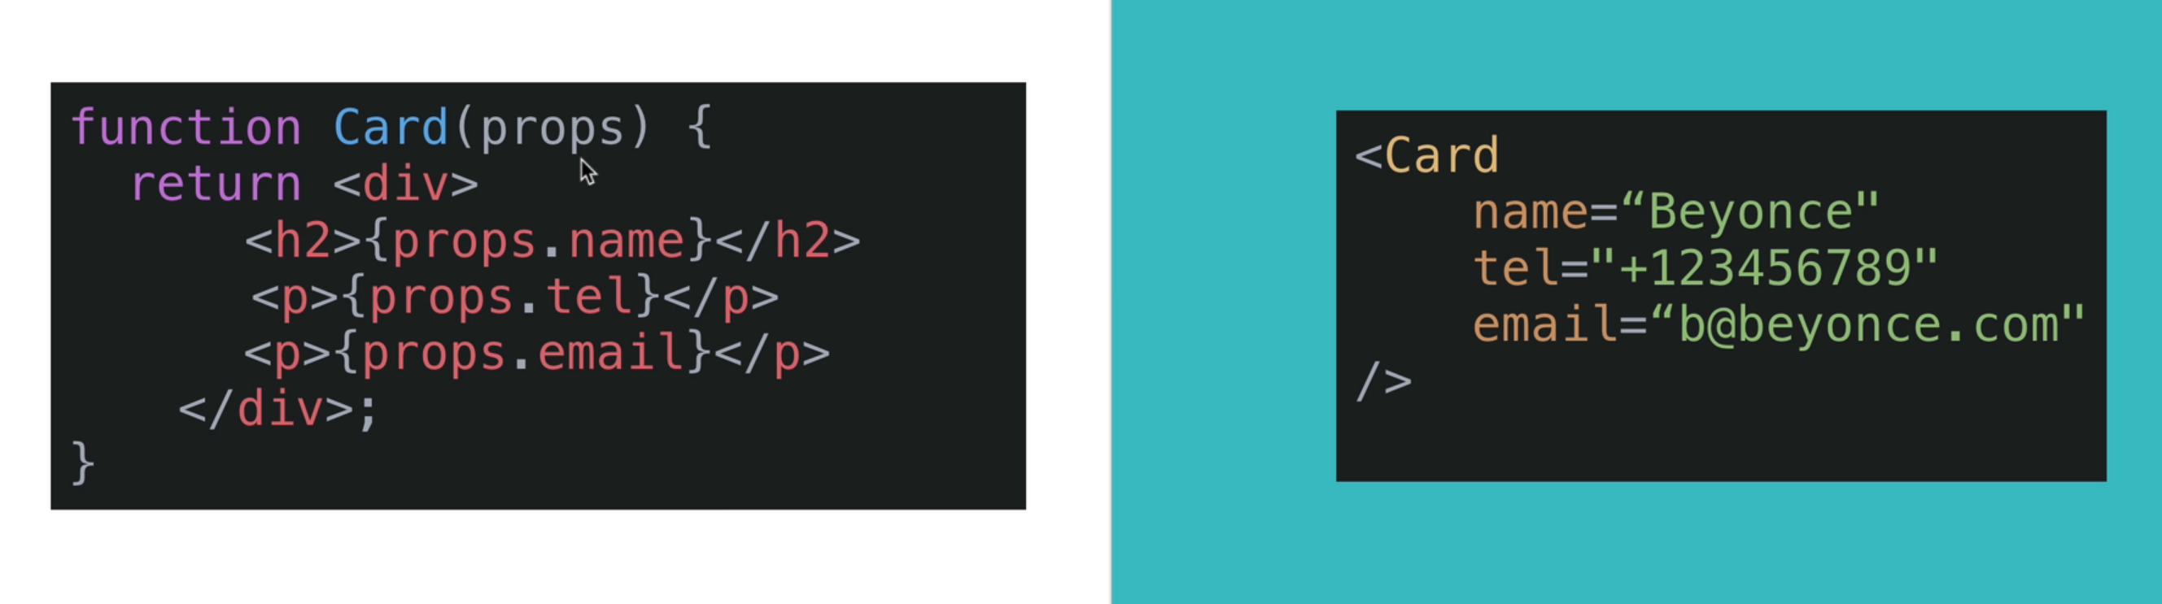

Noe:

* To make an image circular, set its border-radius to 50%.
* Functional programming is the programming paradigm in which one or more functions are passed inside a functions as parameters instead of variables.

Mapping data to components in React (map)

* We can use the map property of react to map data to components so as to use the data efficiently.
* In React, the map function is commonly used to loop through an array of data and create a new array of React components based on that data.
* This can be useful for rendering dynamic lists of data or repeating a certain component multiple times with different props.
* Here, in this example, map loops through each javascript object in the contact array and calls a createCard function on the objects thereby reducing repititions for specifying each object explicitly in the index,js file.
* 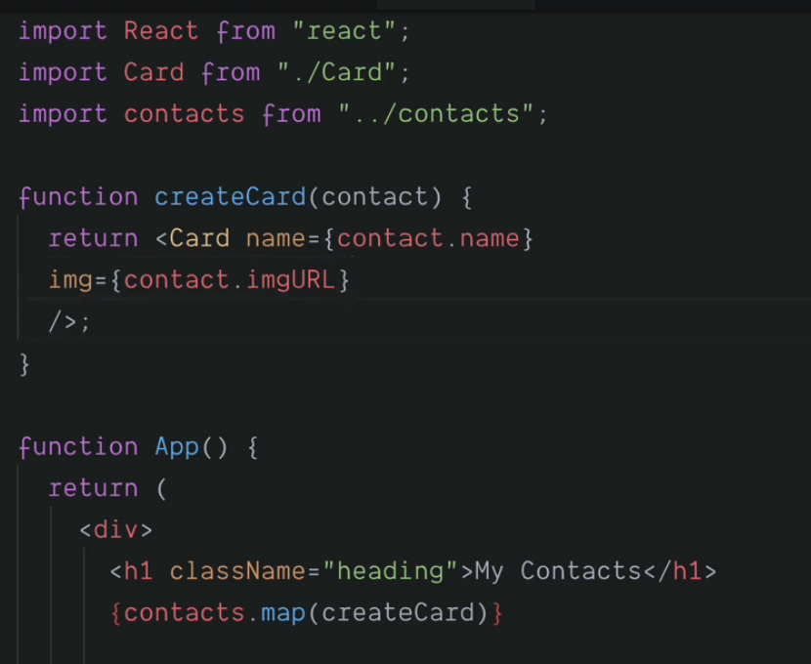
* Abcd
* Looping through an array

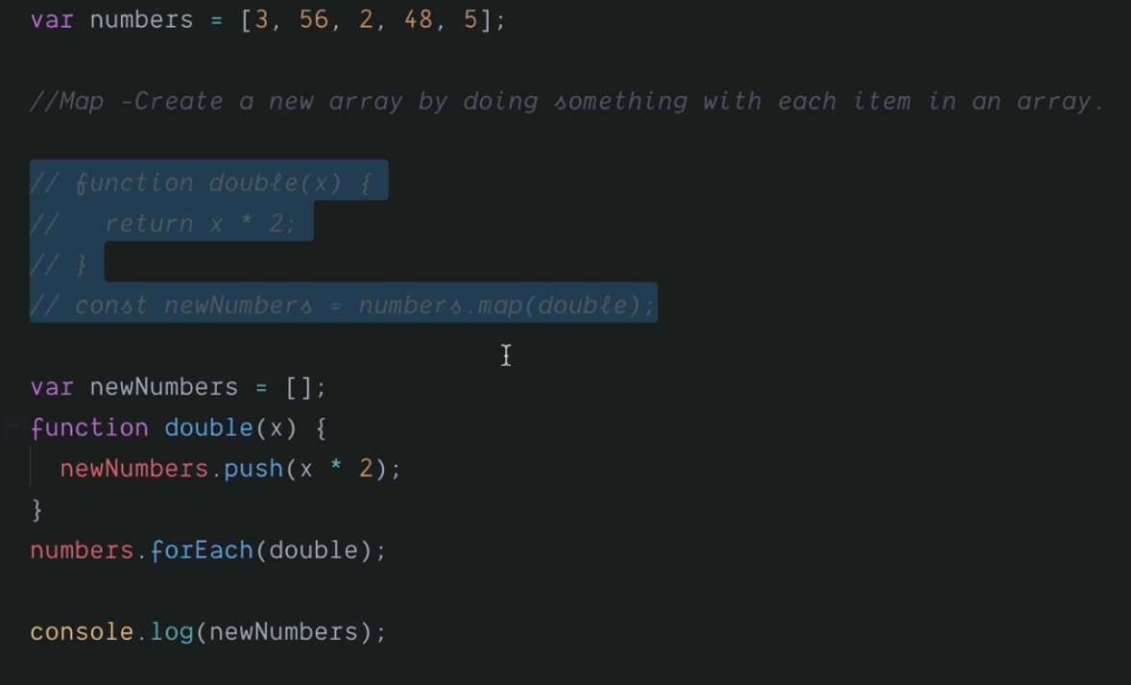

Alt: Use anonymous functions to make the code more concise

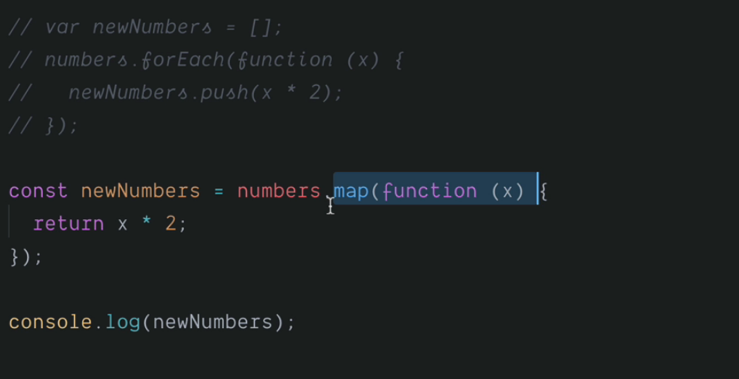

Key Attribute while using map

* In React, the key attribute is used to identify each child element in an array of components or elements.
* The key should be a unique identifier for each element and is necessary for performance optimization and avoiding errors during updates.
* React uses the key to determine which elements have changed and need to be re-rendered, which can help improve the performance of your application.
* Without a key, React will issue a warning in the console and may perform poorly when updating the list.

Filter function in React

* We can use the filter method to reduce our output array.
* It loops through the input array and create a new array by keeping the items that return true.

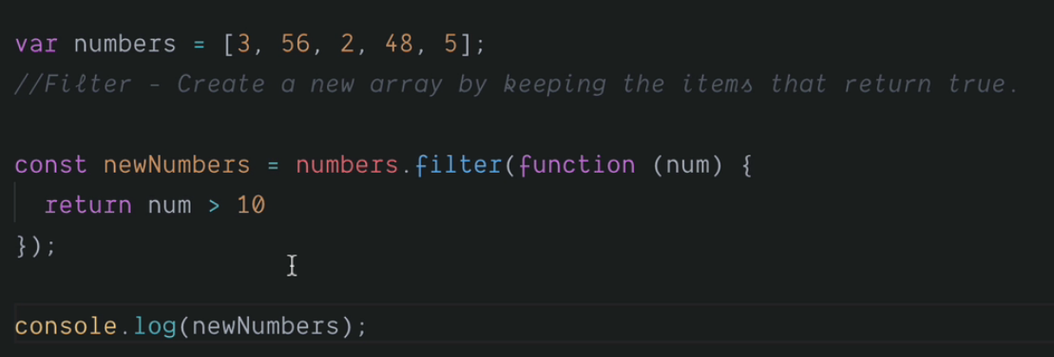

O/P: 56, 48

Reduce function in React

* This function accumulates a value by doing something (addition, subtraction, ..) to each item in the array.
* 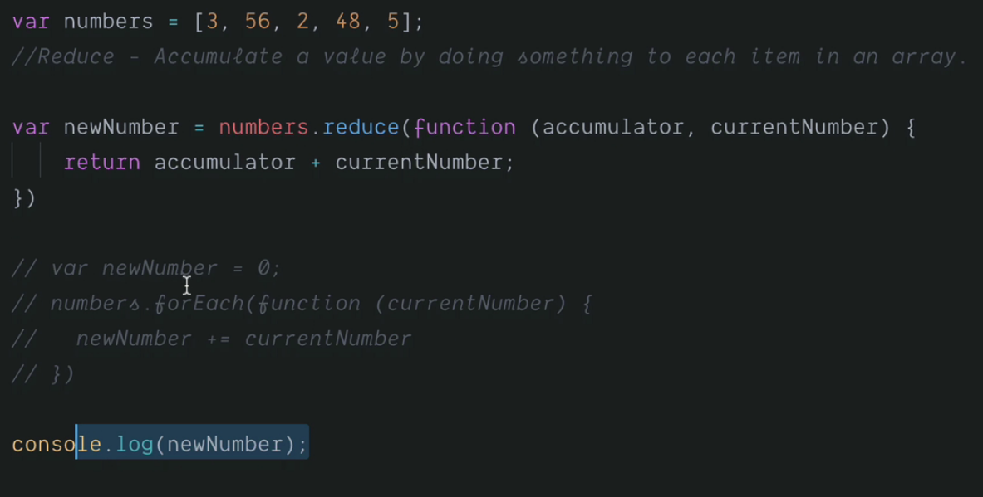
* We can use this function to make our program more concise.

Find Function in React

* Find function finds the first value that matches the condition from an array.
* It loops through the array and stop and return as soon as an item matches the specified condition.

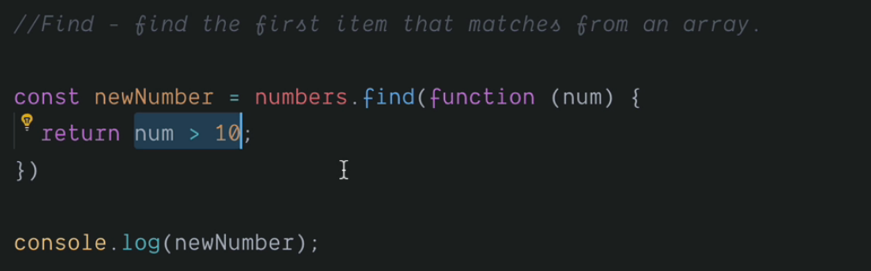

FindIndex function in React

* It works same as the Find function.
* Instead of return an item, it returns the first index that matches the specified condition.
* Using map function to cut down the length of emoji meanings upto 100 characters.

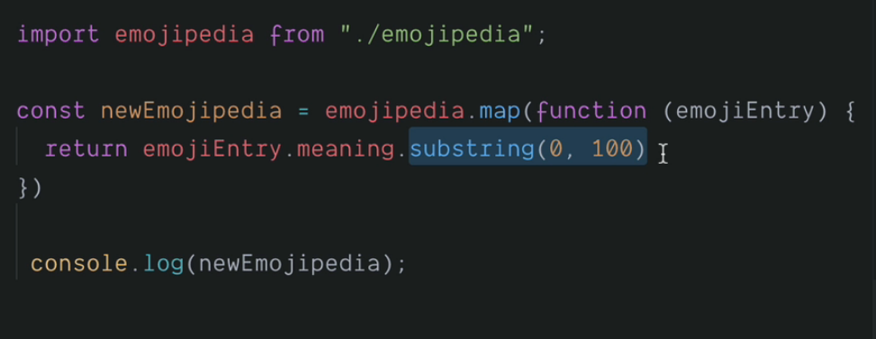

Arrow Functions

* In javascript, when a function is passed as a parameter, we have multiple ways to represent it.
* One being explicitly representing it using the keyword function, followed by function name and parameters.
* We can also use anonymous function to represent them where we use the keyword ‘function’ only and omit the function name.
* We can also omit the function keyword and replace it using a fat array ( => ) right after the parameters. This representation in known as Arrow notation.
* 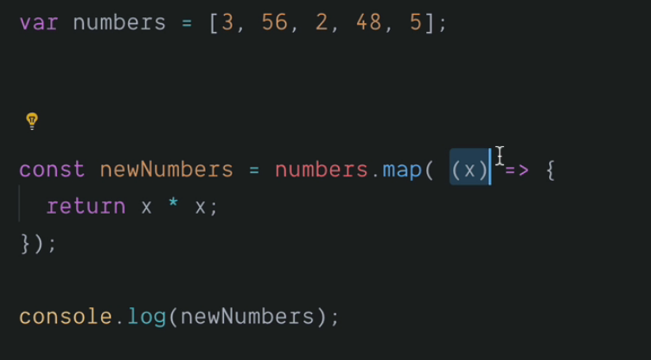
* If we have a single parameter and a single instruction inside the function, then we can further optimize the lines of code and make it more precise as:
* 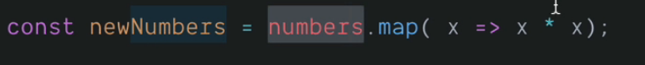

Keeper App Part 2

* An array of javascript object containing notes is included in the nodes.js file and each of the object is displayed by traversing through the array using map function.

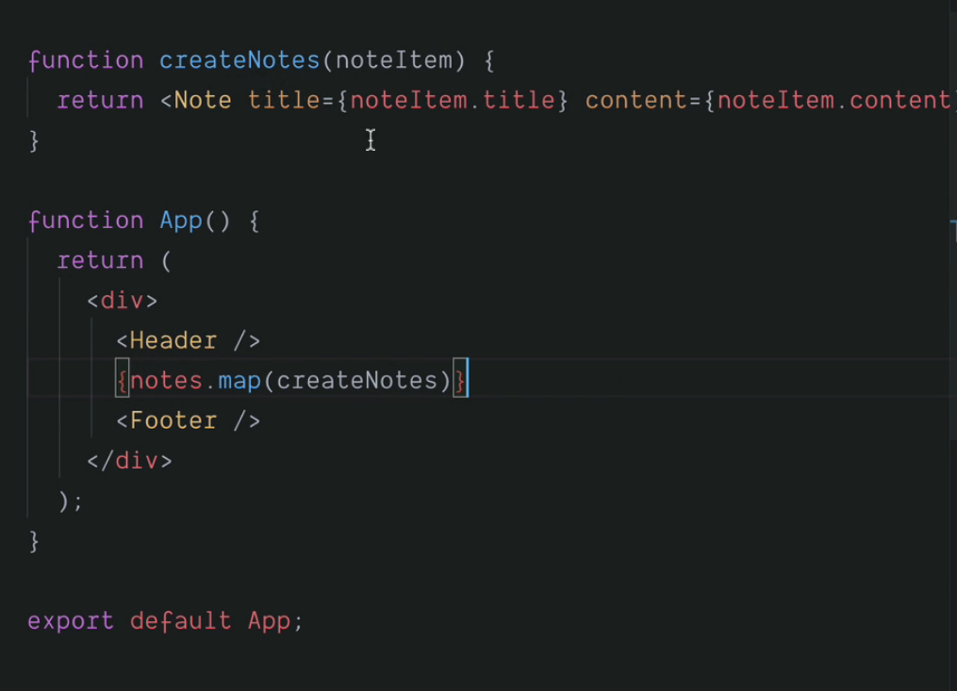

React Conditional Rendering with the Ternary Operator & AND Operator

* Single Responsibility Principle
* The return statement inside a javascript function can contain only an expression and not any statement. So, in case we have to implement any if-else statement, we can use ternary operators.

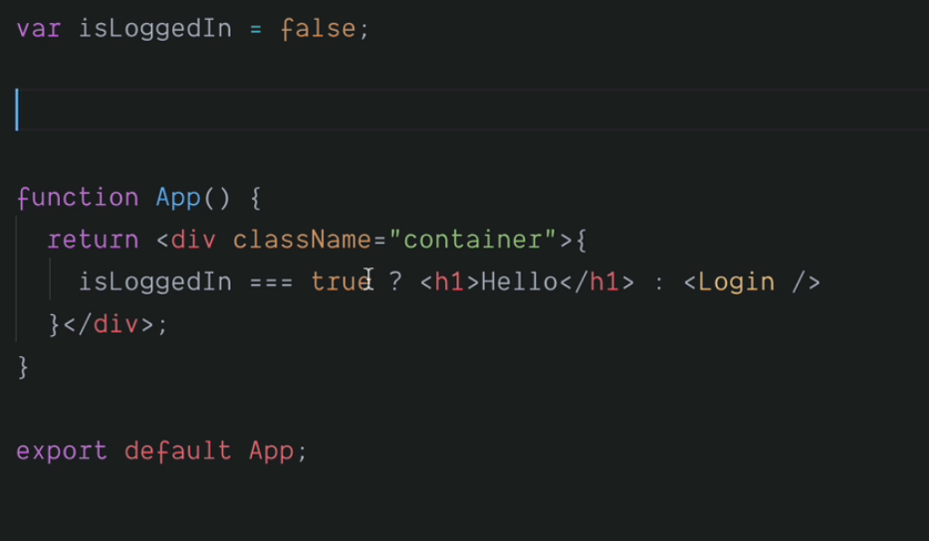

* When we doesn’t want to return anything based on the result of ternary operator, we simply put it as null.

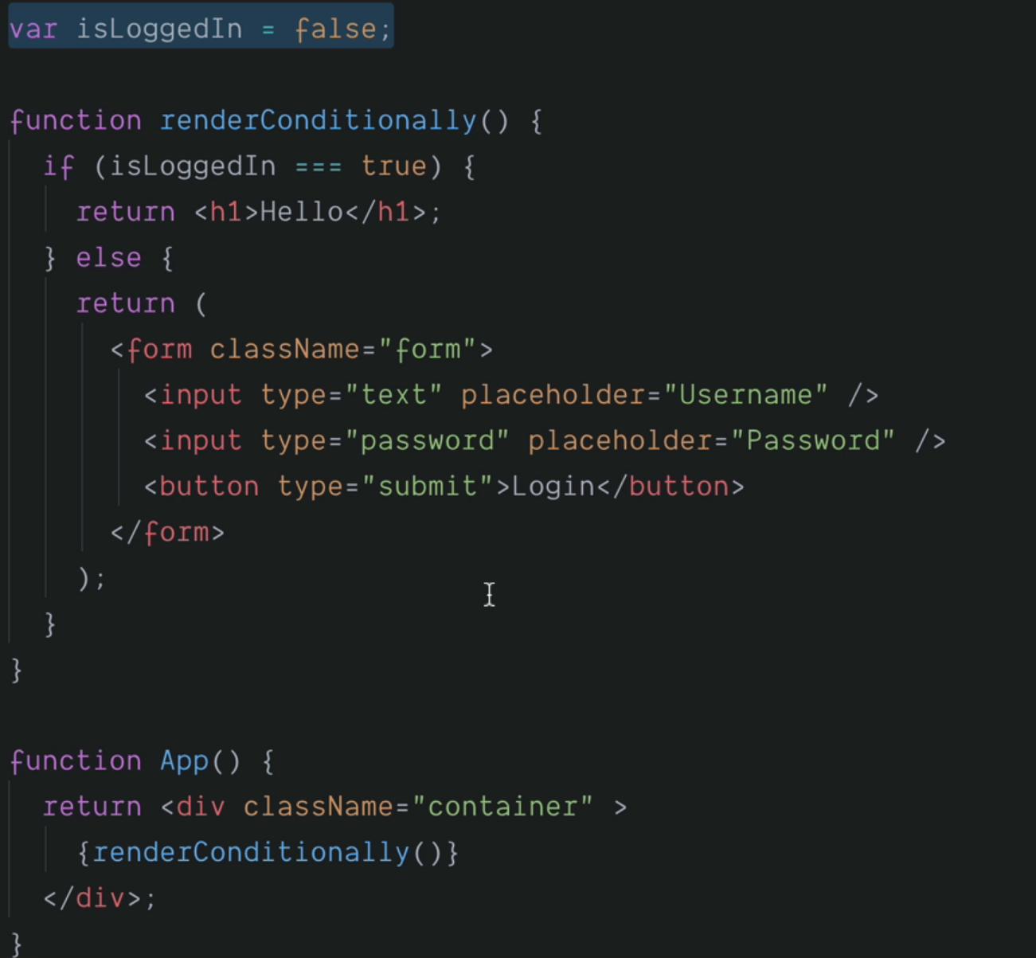

* AND operator : &&

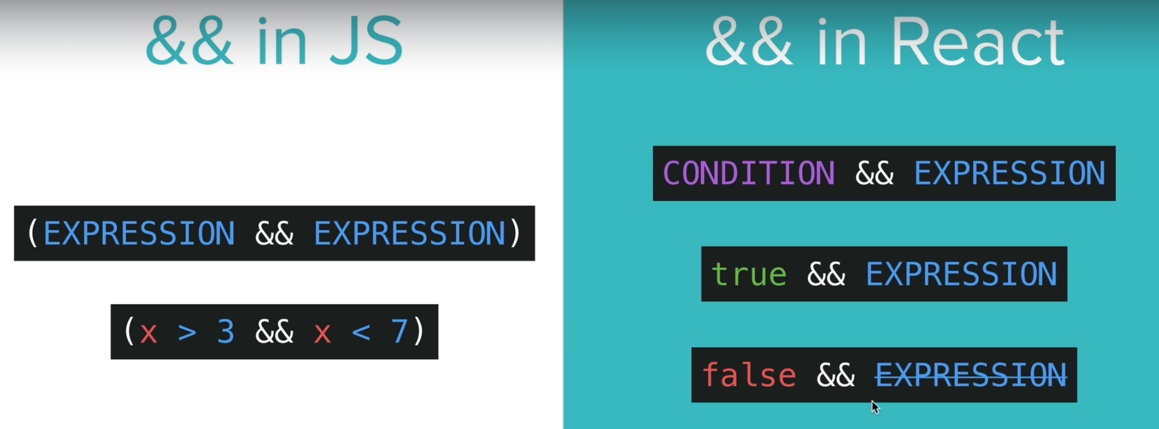

* Instead of using null to not display anything on the screen, we can use AND operator also which renders the second expression only if the first expression is true.



Conditional Rendering Practice

* Show the Confirm Password input only if the user in not registered.

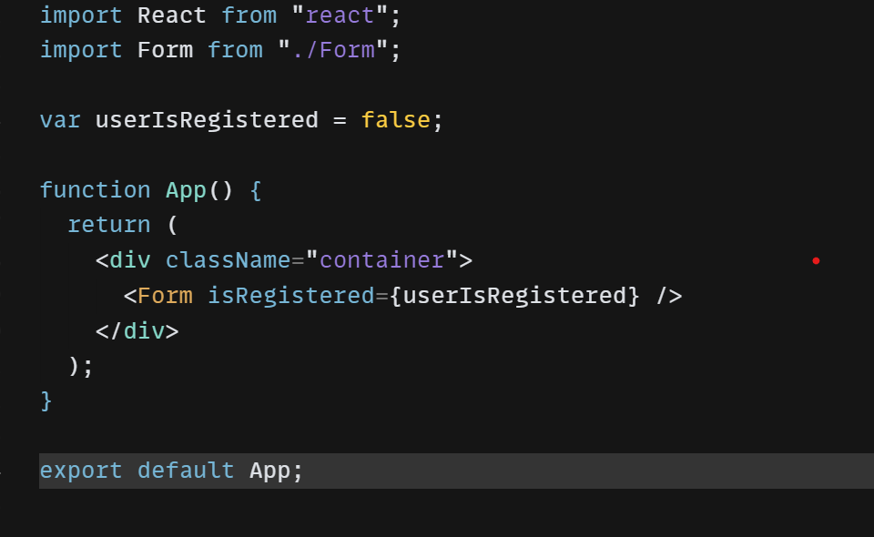

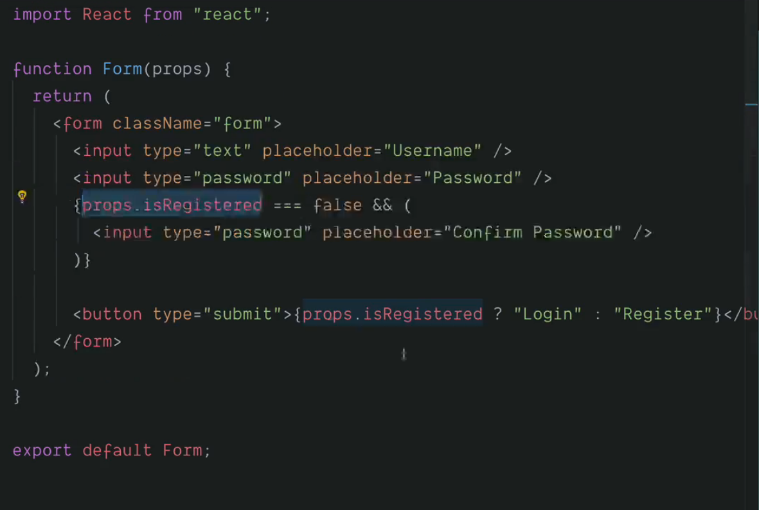

Here, the variable userIsRegistered is passed from the App.js to the form.js as a prop, which uses it and manipulate the rendering of the webpage.

States in React

* In React, a state is a plain JavaScript object that holds data and controls the behaviour of a component.
* The state of a component can be changed over time through user interaction or other events, and when the state changes, the component will re-rend
* er to reflect the updated state.

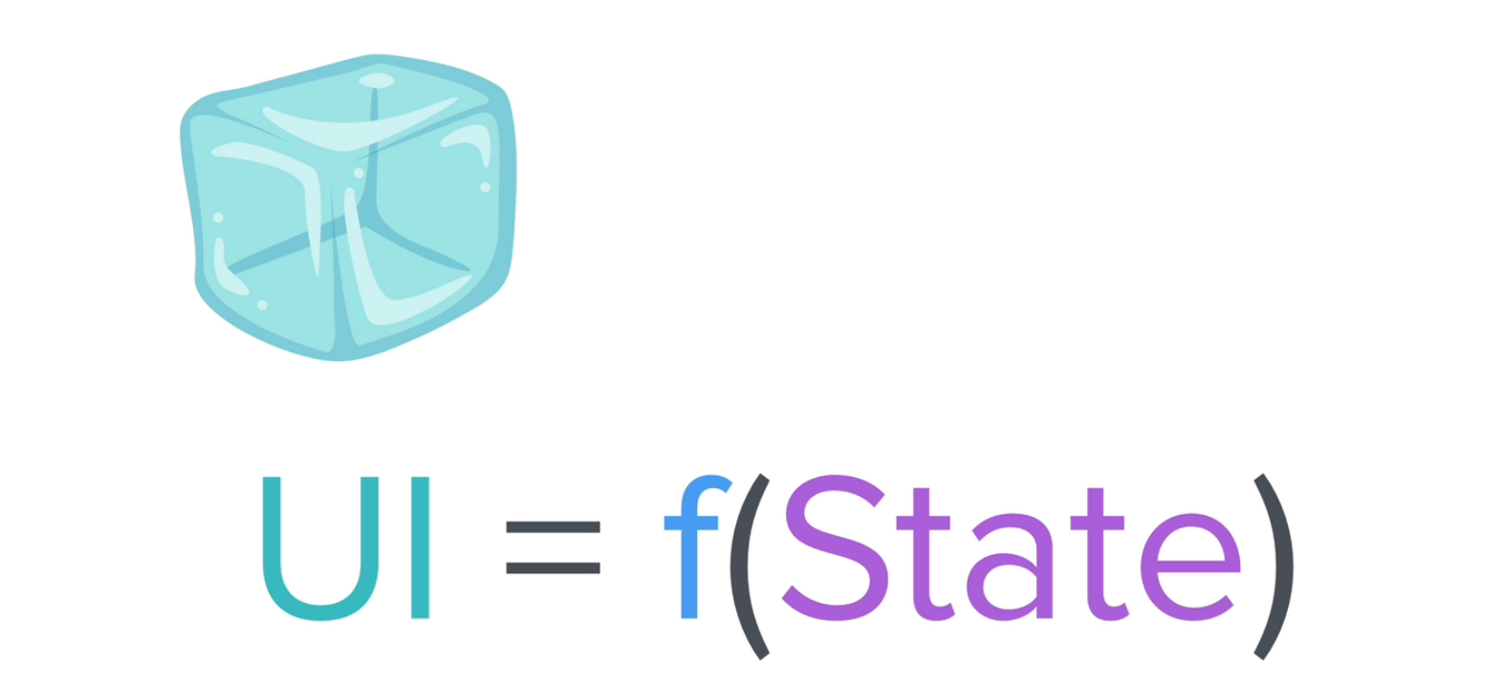

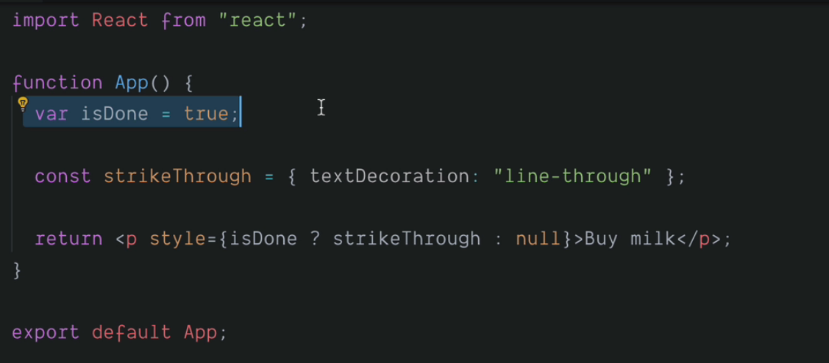

* In this project, we have a user interface (paragraph) which is dependent on the value of a state variable (isDone).
* This type of programming paradigm is known as Declarative Programming. We are declaring while writing the code, how our user interface will look under different conditions dependent upon the states.
* The other paradigm of programming is imperative programming where we imperatively decide how our user interface will look like when the particular line of code is executed.

i.e., getting hold of an item and changing its value each time we want to do so.

For example:

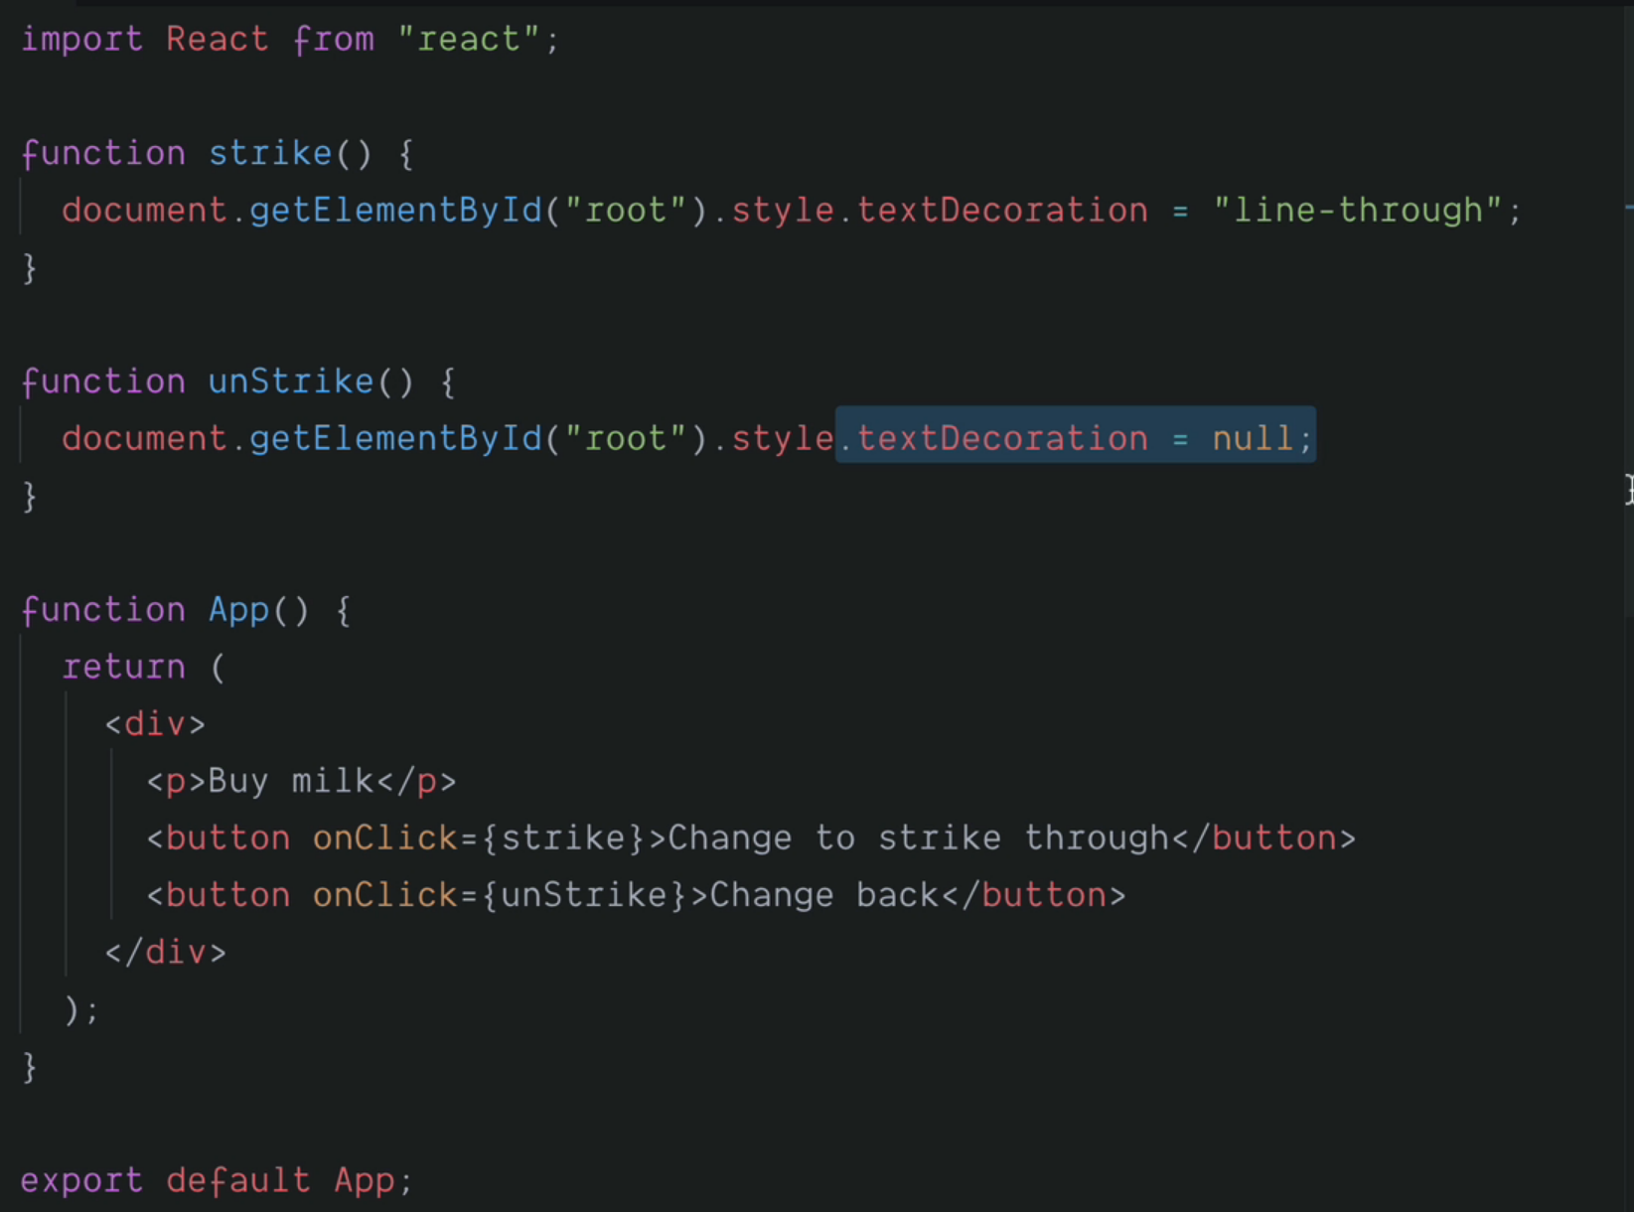

Note:

* Destructuring in ES6: changing complex strucures to simpler ones. Complex structures in javascript are arrays and objects.
* E.g., rgb colour of electron blue colour

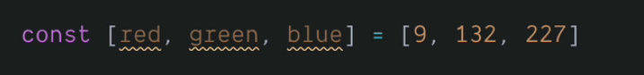

Hooks in React

* Hooks are a new feature introduced in React 16.8 that allow you to use state and other React features without writing a class.
* They are functions that let you "hook into" React state and lifecycle features from function components.

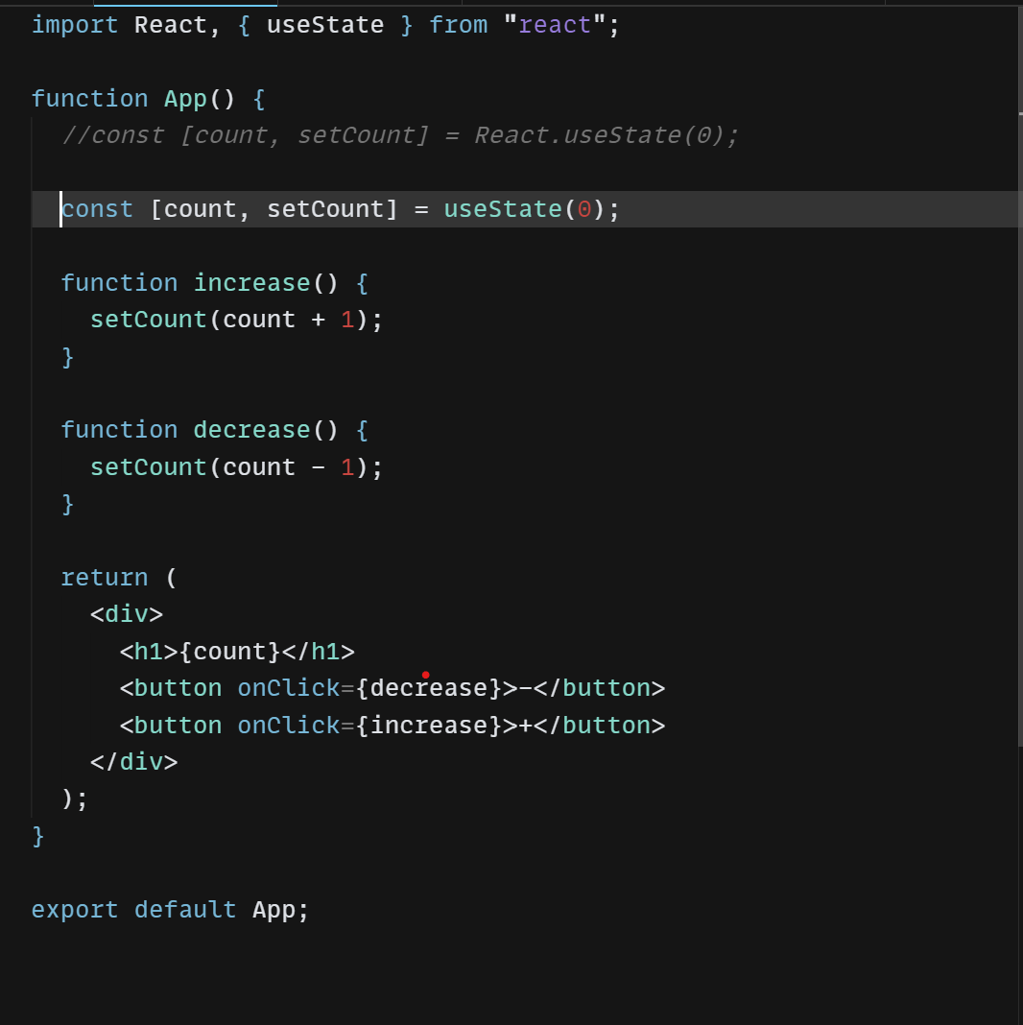

* The return type of useState hook is a {state, function}.

Hooks Practise

* Updating the time every time the getTime button is clicked.

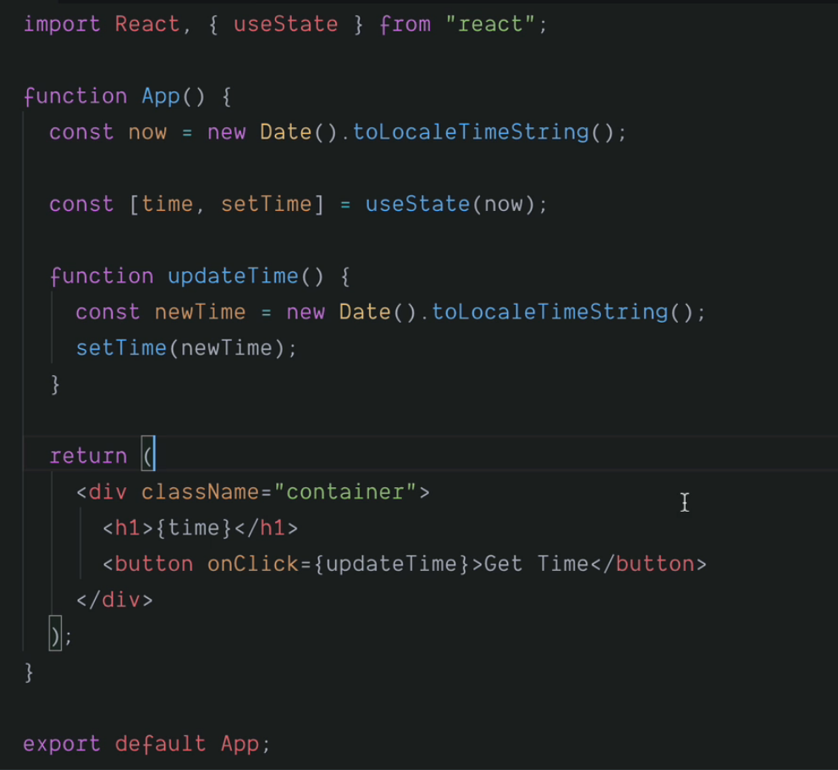

* If we want to update the time dynamically every second, we can simply use the setInterval method.
* Set interval method takes two parameter, currentTime or any function and time-interval.

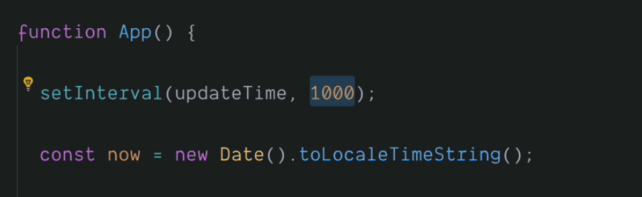

Javascript ES6 Object & Array Destructuring

Event Handling in React

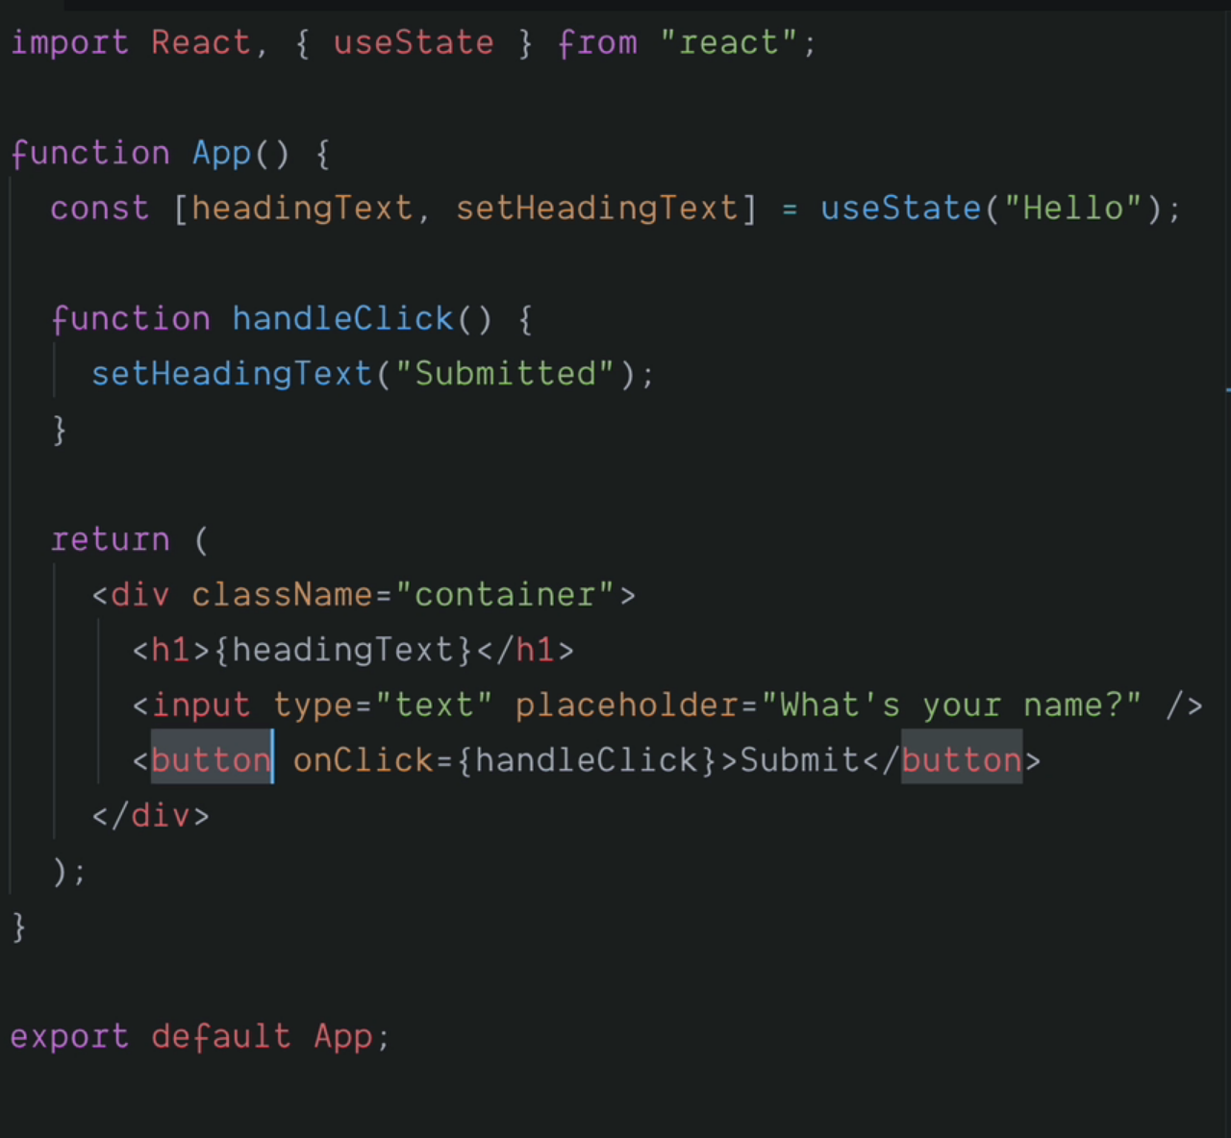

Handling mouse-over, mouse-out and on-click events

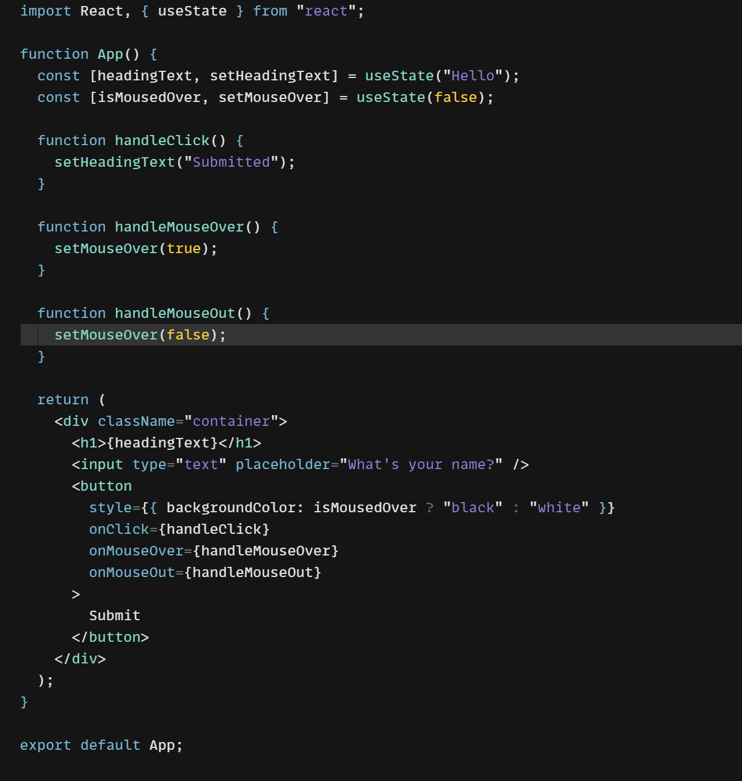

Forms in React

* In react, we have an event listener onChange which gets triggered when there is any change in the input field and creates an object named event which keeps track of the event making the change.
* To get the value of the event causing the change, we can get it from the value of the event object. Thus, we can get hold of any data entered in the input field. 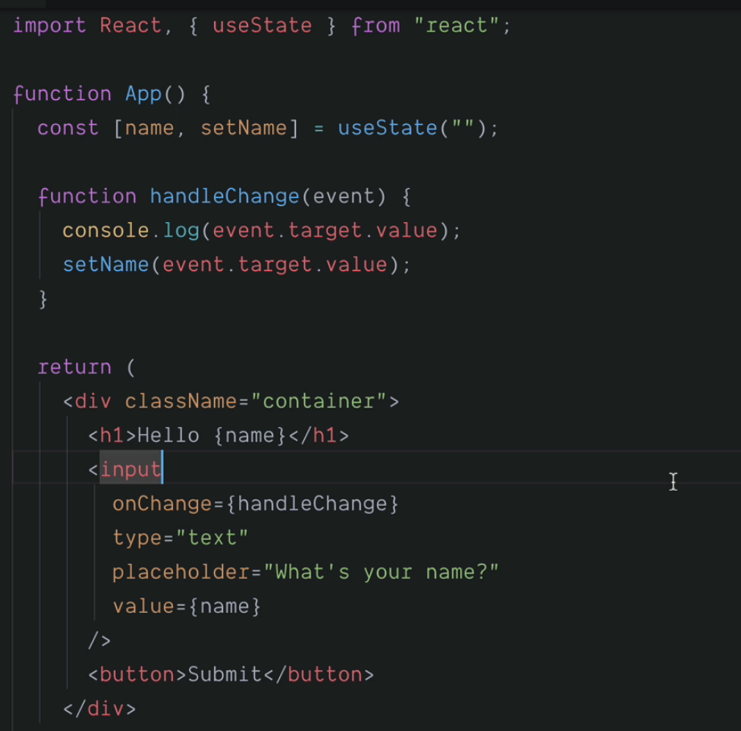
* Controlled Components
* In web development, a controlled component is a type of component in a form where the value of the input element is controlled by the application's state rather than the DOM.
* In other words, the value of the input element is bound to a state variable in the component's code. Whenever the user types or selects a new value in the input element, the state variable is updated, and the component is re-rendered with the new value.
* This allows the application to have full control over the input value and to implement features such as validation, input masking, and error handling. Controlled components are commonly used in React applications, but they can be implemented in other frameworks and libraries as well.

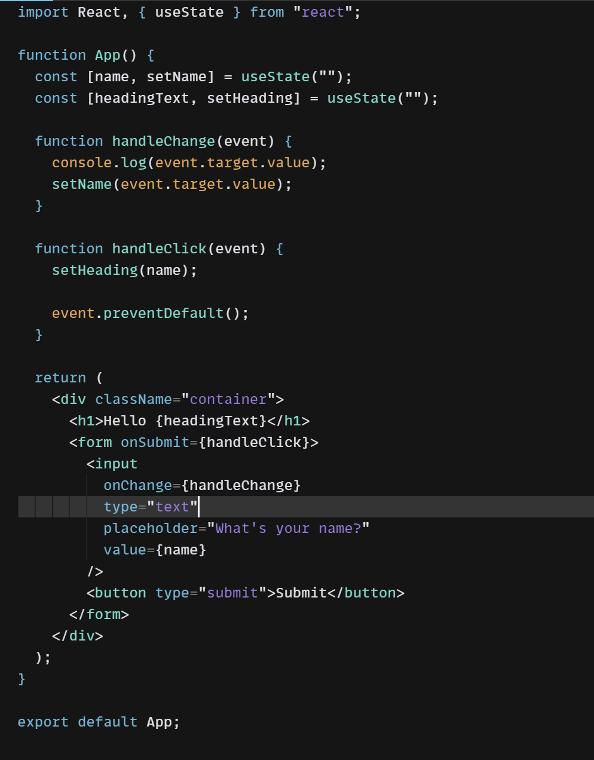

* In the above example, the value variable is controlled by the state hook useState(), and the handleChange() function updates the state whenever the user types in the input element. The handleSubmit() function is called when the user submits the form, and it can access the current value of the input element through the value variable.
* Single source of truth
* In React, a single source of truth refers to the idea of managing state in a centralized location and using that state to render components throughout the application.
* By having a single source of truth for state management, it becomes easier to track and manage the application's state.
* When the state changes, all components that depend on that state will be automatically updated. This avoids inconsistencies and reduces the risk of bugs that can arise from having multiple sources of truth for state management.

Note:

* In HTML and React, when a form is submitted, the default behaviour is for the page to refresh or redirect to a new URL. This can be undesirable in some cases, such as when we want to handle the form submission using JavaScript code without triggering a page refresh or redirect.
* To prevent the default behaviour of form submission, we can use the **preventDefault()** method. This method is called on the event object passed to the **onsubmit** event handler of the form element.